Evidence Output

T012:

Valid last name case.

Input 123 in last name.

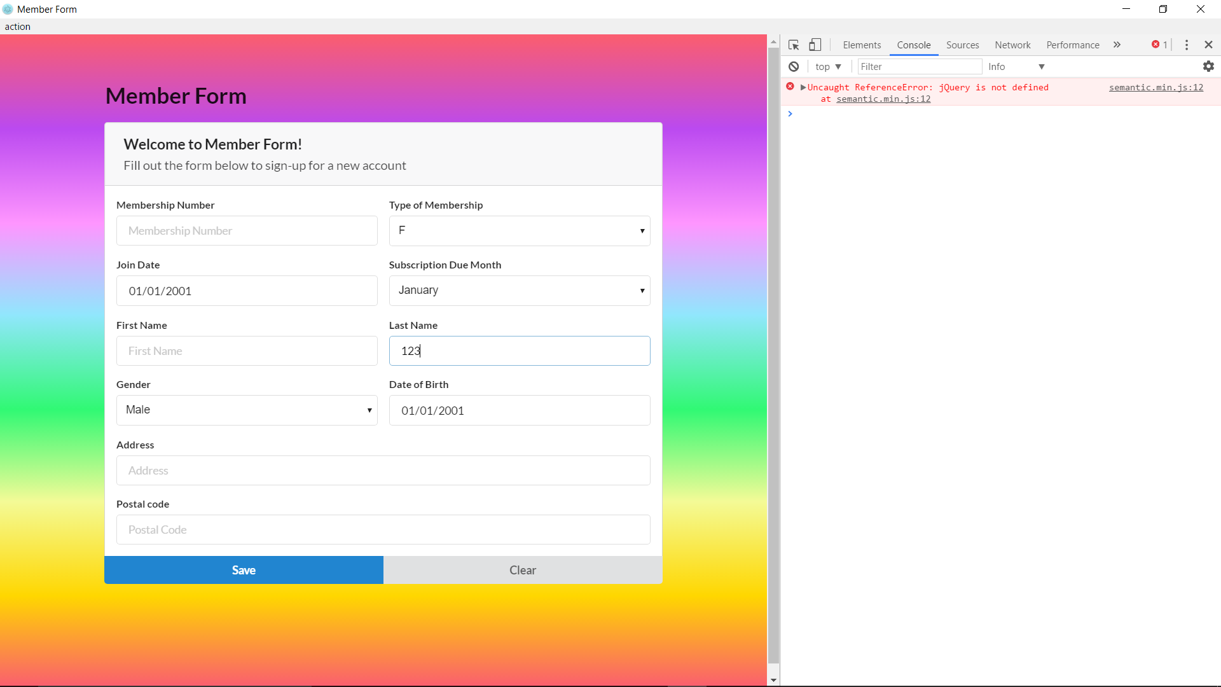

Valid last name case fail.

